1. Go to <https://github.com/anoop387/TrafficCityWarriors>
2. Download Folder (TrafficCityWarriors-main)
3. Open DataProfiling Project in PyCharm

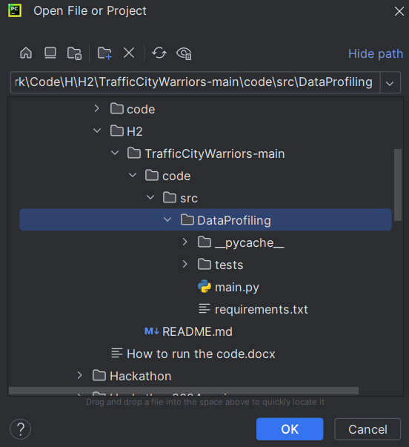

1. Open Terminal and run ***pip install -r requirements.txt***

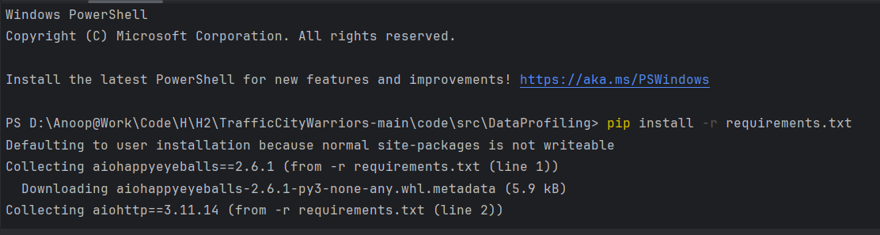

1. Create Virtual Environment & Install Requirement

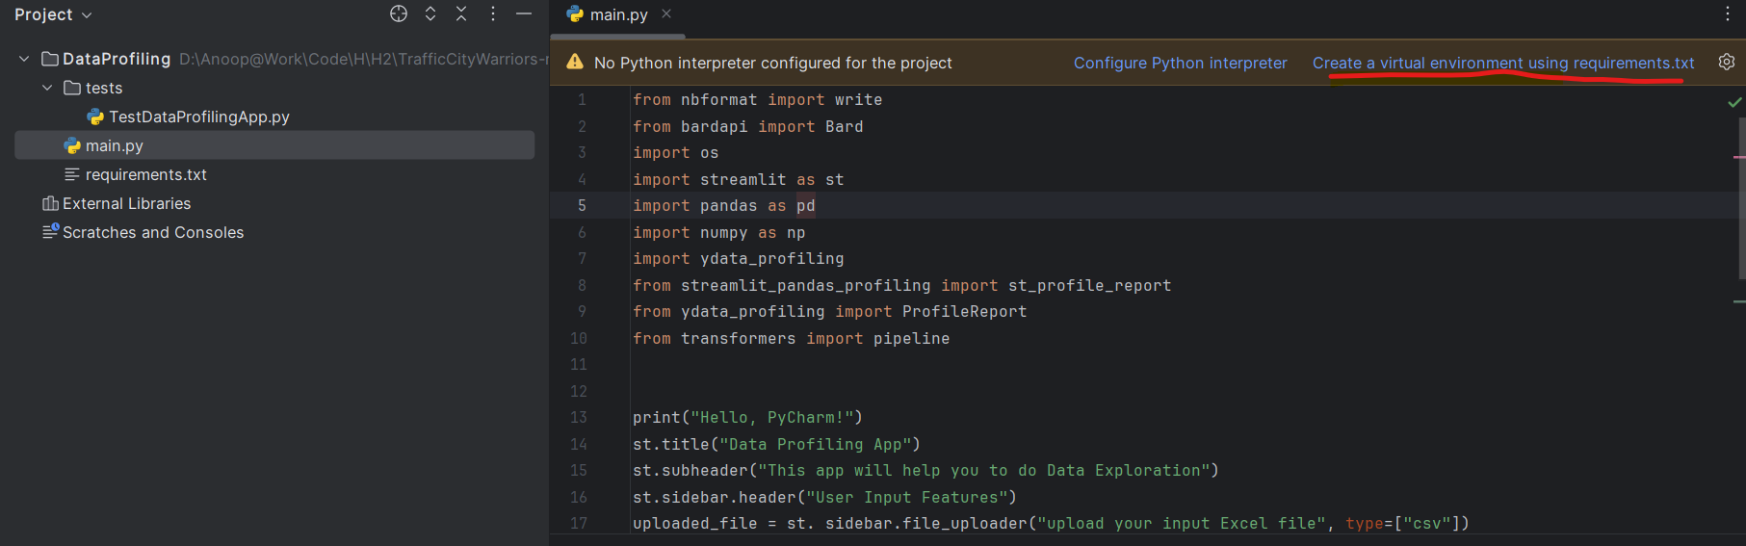

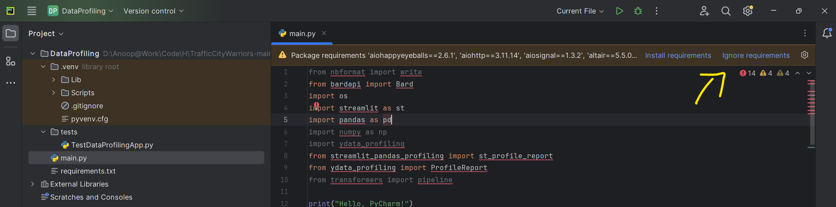

Note : It will take approx. 5 mins

1. Run the Project

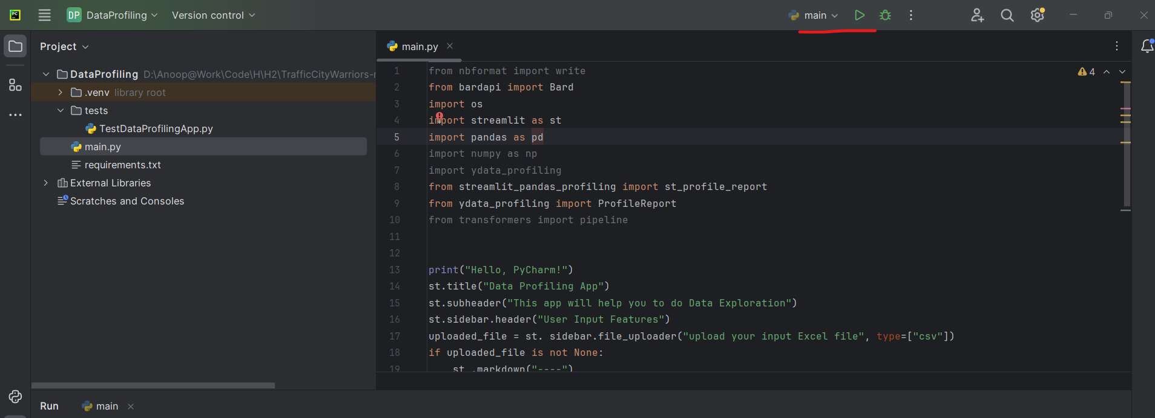

1. Open Terminal in .venv and run **streamlit run main.py**

Close the Terminal Select .venv using mouse then Open Terminal

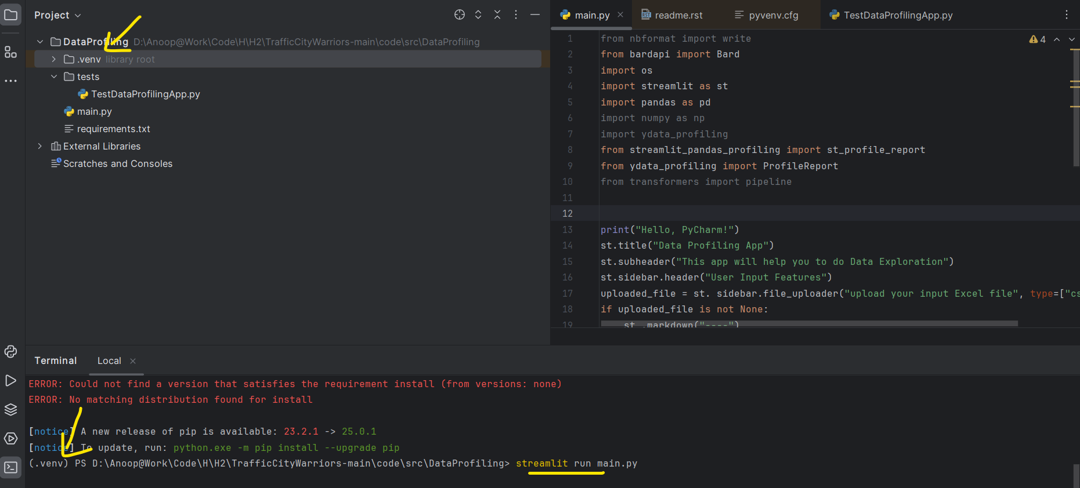

1. Open the URL in Browser

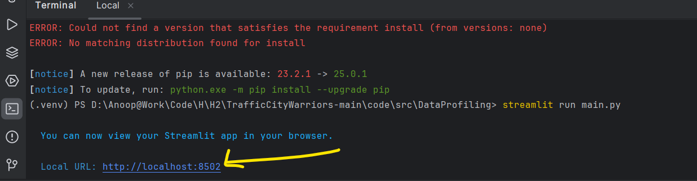

Application Screen Shot is mentioned in ppt & captured flow in video